

LAB EXPERIMENT RECORD
SET 25: WEBSITE ANALYSIS

Department | Artificial Intelligence and Data Science
Course Code / Course Name | DSA0601 / Data Handling and Visualization
Name / Register Number | ROHAN P T / 192424112
Date / Day | 20/10/2026

Aim
To analyze website traffic analysis using the requested visualizations and dashboard views.

Dataset
Website Traffic Analysis
Date | Page_Views | Click_Through_Rate | Likes | Shares | Comments | Traffic_Source | Source_X | Source_Y | Source_Page_Views
2023-01-01 | 1500 | 2.3 | 120 | 35 | 18 | Search | 0.18 | 0.68 | 620
2023-01-02 | 1600 | 2.7 | 145 | 42 | 21 | Social | 0.52 | 0.78 | 410
2023-01-03 | 1400 | 2.0 | 105 | 28 | 16 | Direct | 0.75 | 0.46 | 260
2023-01-04 | 1650 | 2.4 | 150 | 38 | 24 | Referral | 0.35 | 0.29 | 190
2023-01-05 | 1800 | 2.6 | 172 | 48 | 27 | Email | 0.85 | 0.22 | 320

R Data Setup
Run this setup once before the R programs below. The dataset is defined inline so each record can be copied and run without a separate CSV file.
R data setup
dat <- data.frame(
Date = c("2023-01-01", "2023-01-02", "2023-01-03", "2023-01-04", "2023-01-05"),
Page_Views = c(1500, 1600, 1400, 1650, 1800),
Click_Through_Rate = c(2.3, 2.7, 2.0, 2.4, 2.6),
Likes = c(120, 145, 105, 150, 172),
Shares = c(35, 42, 28, 38, 48),
Comments = c(18, 21, 16, 24, 27),
Traffic_Source = c("Search", "Social", "Direct", "Referral", "Email"),
Source_X = c(0.18, 0.52, 0.75, 0.35, 0.85),
Source_Y = c(0.68, 0.78, 0.46, 0.29, 0.22),
Source_Page_Views = c(620, 410, 260, 190, 320)
)
dat$Date <- as.Date(dat$Date)

PROGRAM 1: Page Views Over Time
Create a labeled Tableau line chart showing page views over time.
R code
plot(dat$Page_Views, type="o", xaxt="n", xlab="Date", ylab="Page views", main="Page Views Over Time", col="#276B9A")
axis(1, at=seq_len(nrow(dat)), labels=dat$Date)

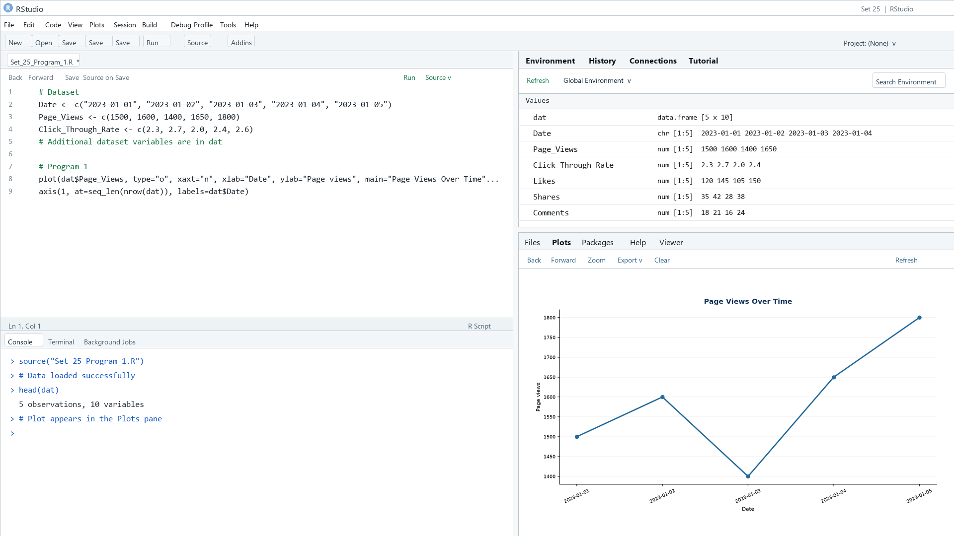
Output 1: Page Views Over Time
Observation: Page views reach 1,800 on January 5 after a temporary dip on January 3.

PROGRAM 2: Click-Through Rates by Day
Create an R bar chart of the days with the highest click-through rates.
R code
barplot(dat$Click_Through_Rate, names.arg=dat$Date, col="skyblue3", xlab="Date", ylab="CTR (%)", main="Top Click-Through Rate Days")

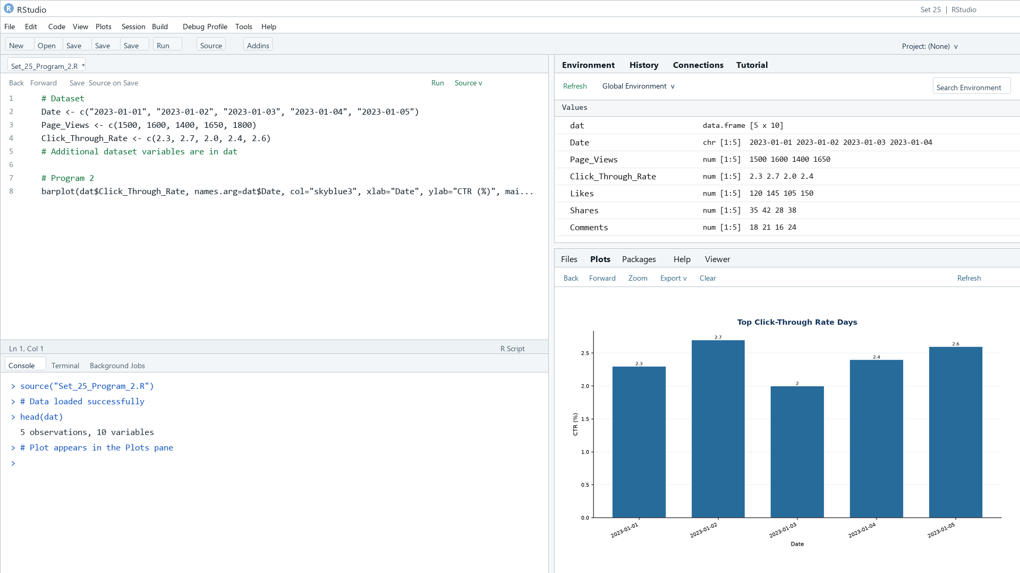
Output 2: Click-Through Rates by Day
Observation: January 2 has the highest rate (2.7%), followed by January 5 (2.6%).

PROGRAM 3: Website Interaction Area Chart
Create an R stacked area chart showing likes, shares, and comments over time.
R code
library(ggplot2)
long <- reshape(dat, varying=c("Likes","Shares","Comments"), v.names="Count", timevar="Interaction", times=c("Likes","Shares","Comments"), direction="long")
ggplot(long, aes(Date, Count, fill=Interaction)) + geom_area() + labs(title="User Interactions Over Time", x="Date", y="Interactions") + theme_minimal()

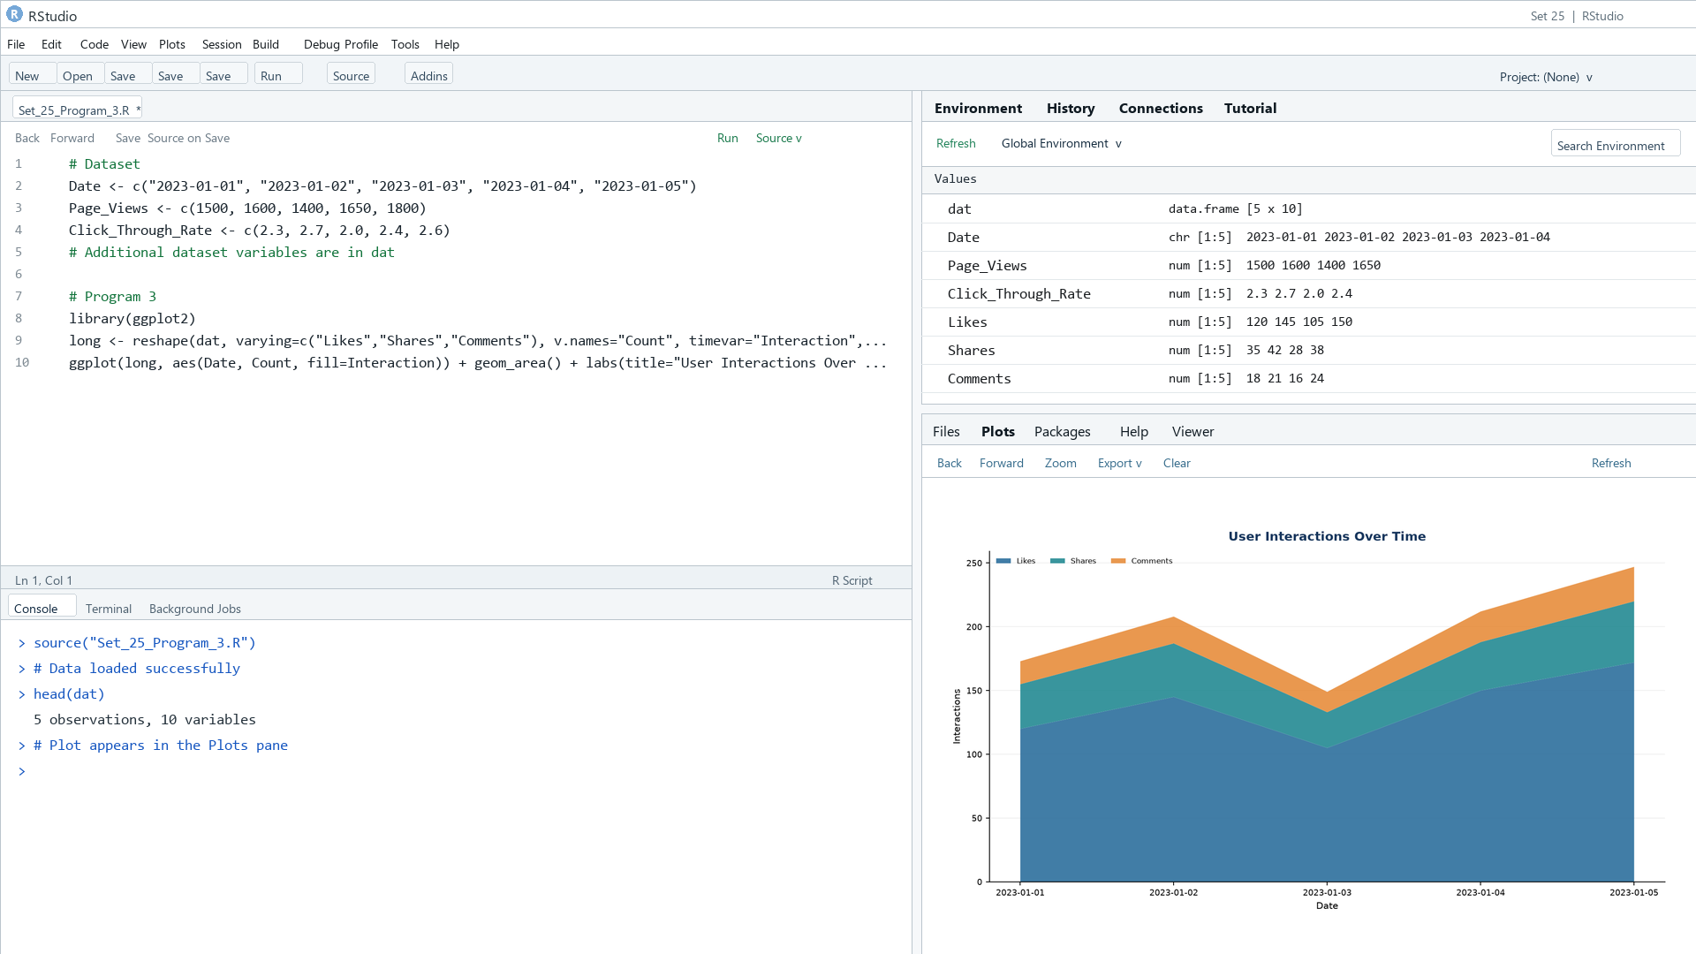
Output 3: Website Interaction Area Chart
Observation: Likes contribute the largest interaction count on each date; interactions are illustrative values.

PROGRAM 4: Traffic Source Dashboard
Create a Tableau dashboard with an interactive traffic-source map and a bar chart of page views by source.
Tableau build steps
Tableau dashboard build
1. Connect to the daily traffic table and replace schematic locations with real source geography if available.
2. Create a map using Source_X and Source_Y, sized by Source_Page_Views.
3. Create a bar chart of Source_Page_Views by Traffic_Source.
4. Add Date and Traffic_Source filters, then combine map and chart on a dashboard.

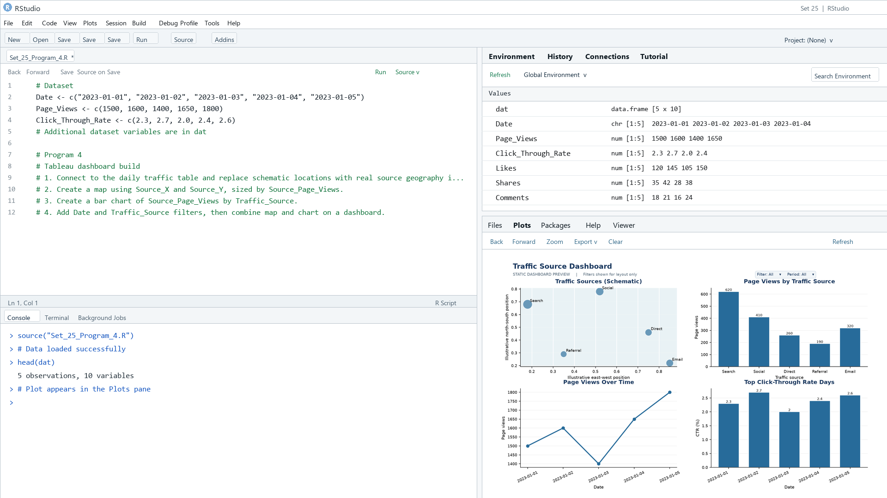
Output 4: Traffic Source Dashboard
Observation: The preview shows a schematic traffic-source map and page views by source alongside daily traffic context. Source locations and source counts are illustrative.

Procedure
1. Review the dataset table and confirm any illustrative fields noted in the record.
2. Run the R setup block once, then run the requested program code.
3. Compare the output screenshot with the observation and replace illustrative values when actual data is available.
4. For Tableau tasks, connect to the displayed data and follow the dashboard build steps.

Result
The requested charts and dashboard views for Set 25 were prepared from the displayed dataset. Outputs include labels, short observations, and code or dashboard construction steps.

Key Functions Used
plot(), barplot(), hist(), boxplot(), table().

